**Kernel upgrade in D35**

# Planning and Review

## Current Versions

Current Kernel Version (./disp+work)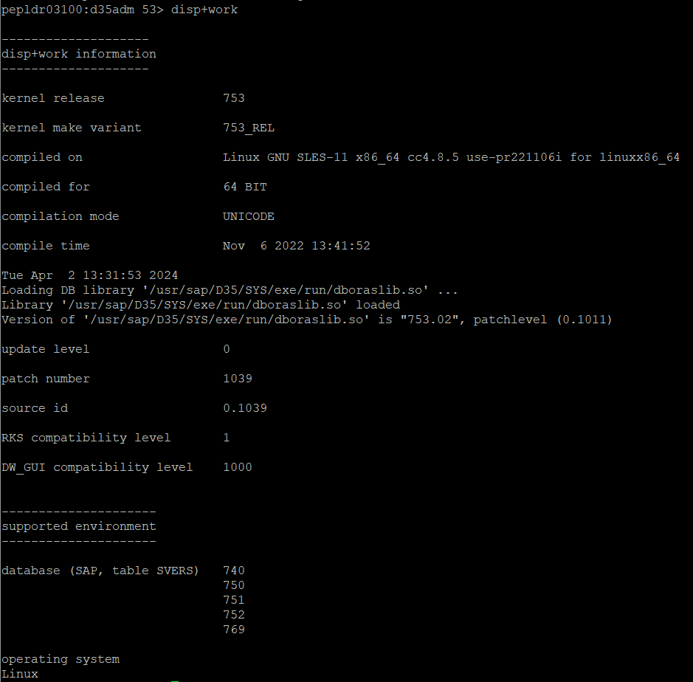

Current IGS Version

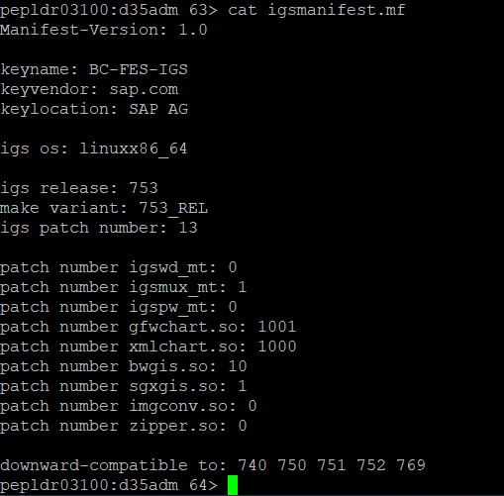

Current IGS Helper Version

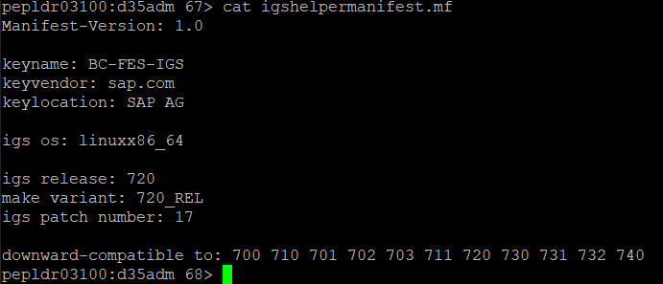

Current BRTOOLS version (if oracle)

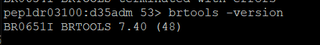

## Target version Excel

## Regression Notes

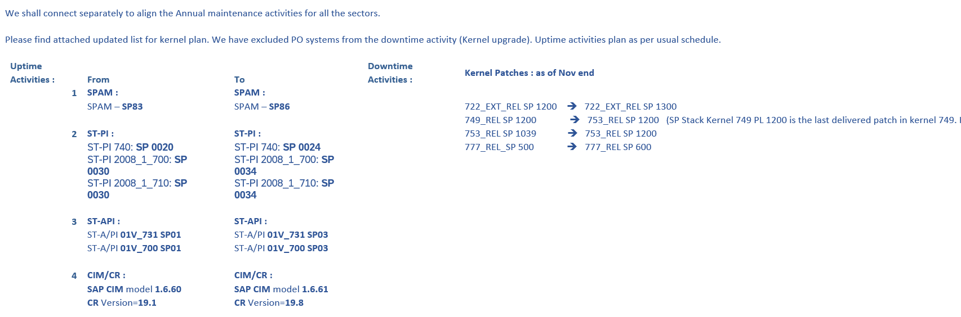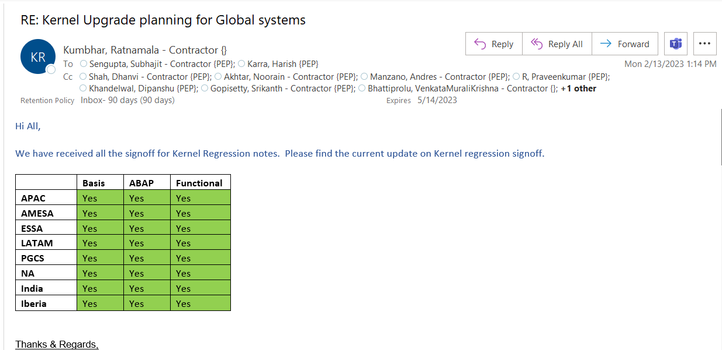

## Regression Notes Signoff



# Pre-checks

## Verify if all the servers have shared global mount /sapmnt/SID. If it is not shared mount, need to fix it before kernel upgrade

(#df -h)

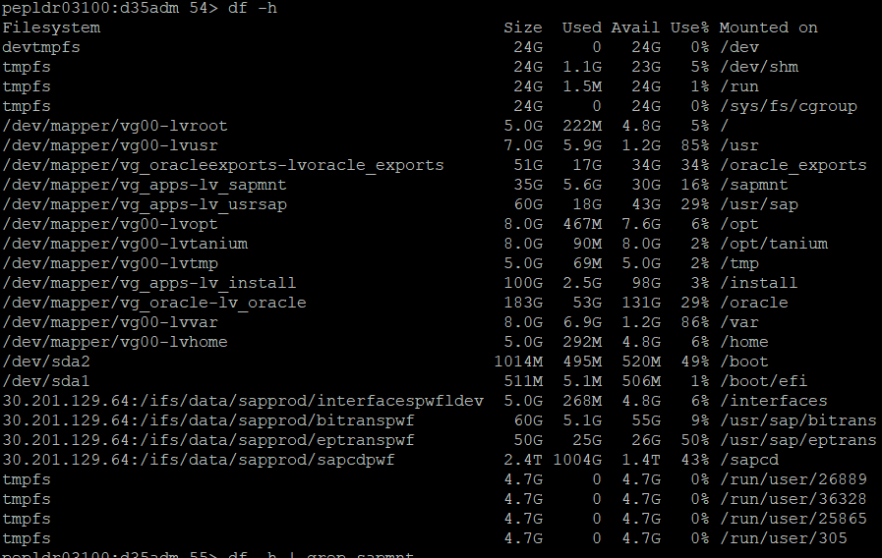

## Creating Backup

(#cp -rp …)

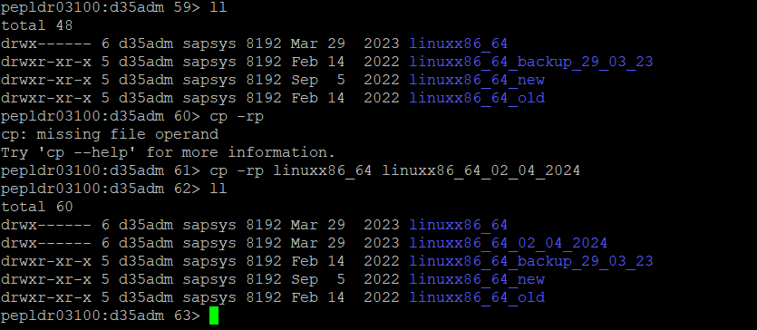

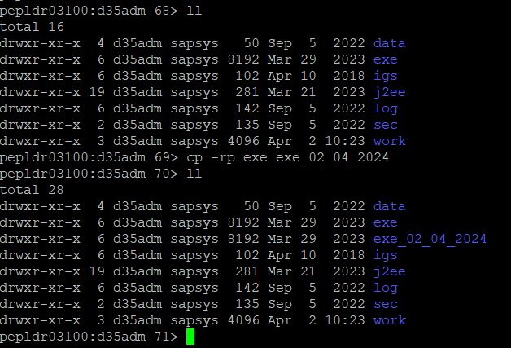

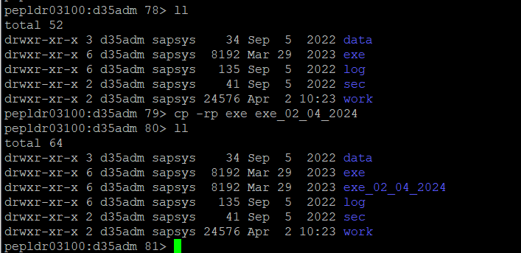

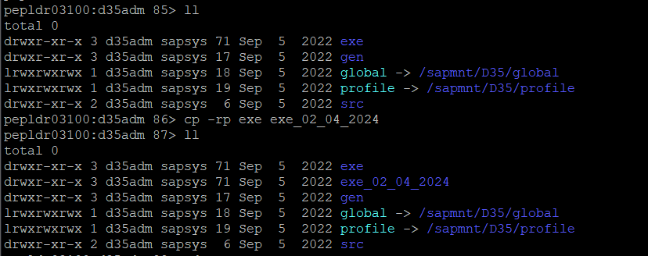

## RSPFPAR & RSPARAM

(T-Code sa38 – ABAP; #SAPPFPAR check pf=.. - JAVA)

|  |
| --- |
| pepldr03100:d35adm 95> sappfpar check pf=D35_J00_sapd35  ================================================  == Checking profile: /sapmnt/D35/profile/D35_J00_sapd35  == SAP Release 753  == SAP Patch 1039  == System ID 390 (AMD/Intel x86_64 with Linux)  == ES Implementation std  ================================================  Metadata Parameters Analysis  ================================================  ***WARNING: Parameter abap/buffersize = 73728  Parameter value out of range (150000 67108864)  ***WARNING: Parameter abap/programs = 18432  Parameter value out of range (37500 16777200)  ***WARNING: Parameter abap/shared_objects_size_MB = 7  Parameter value out of range (10 2147483647)  Parameters Redefinitions  ================================================  Unknown and Obsolete Parameters  ================================================  ***WARNING: Unexpected parameter: icm[J2EE]/enable_icmadm = true  ***WARNING: Unexpected parameter: igs/listener/rfc/disable = 1  ***WARNING: Unexpected parameter: jstartup/max_caches = 500  ***WARNING: Unexpected parameter: jstartup/vm/parameters = -Dsap.runtime.vm.allow=*;SAP*;*;*  Formula Based Parameters  ================================================  Additional Memory and OS Specific Checks  ================================================  Shared Memory Disposition Overview  ================================================  Shared memory pools  Key: 10 Pool  Size configured.....: 200000000 ( 190.7 MB)  Size min. estimated.: 121522000 ( 115.9 MB)  Advised Size........: 124000000 ( 118.3 MB)  Key: 40 Pool for database buffers  Size configured.....: 209715200 ( 200.0 MB)  Size min. estimated.: 1791128820 (1708.2 MB)  Advised Size........: 1794000000 (1710.9 MB)  Shared memories inside of pool 10  Key: 11 Size: 600000 ( 0.6 MB) Factory calender buffer  Key: 12 Size: 6000000 ( 5.7 MB) TemSe Char-Code convert Buf.  Key: 13 Size: 60500000 ( 57.7 MB) Alert Area  Key: 14 Size: 4400000 ( 4.2 MB) Presentation buffer  Key: 16 Size: 21360 ( 0.0 MB) Semaphore activity monitoring  Shared memories inside of pool 40  Key: 42 Size: 485603280 ( 463.1 MB) DB TTAB buffer  Key: 43 Size: 928001424 ( 885.0 MB) DB FTAB buffer  Key: 44 Size: 200641424 ( 191.3 MB) DB IREC buffer  Key: 45 Size: 118721424 ( 113.2 MB) DB short nametab buffer  Key: 46 Size: 160 ( 0.0 MB) DB sync table  Key: 47 Size: 3175424 ( 3.0 MB) DB CUA buffer  Key: 48 Size: 2760160 ( 2.6 MB) Number range buffer  Key: 49 Size: 2224500 ( 2.1 MB) Spool admin (SpoolWP+DiaWP)  Shared memories outside of pools  Key: 1 Size: 512 ( 0.0 MB) System administration  Key: 2 Size: 62424592 ( 59.5 MB) Disp. administration tables  Key: 3 Size: 208896000 ( 199.2 MB) Disp. communication areas  Key: 4 Size: 1047616 ( 1.0 MB) statistic area  Key: 6 Size: 78517248 ( 74.9 MB) ABAP program buffer  Key: 7 Size: 33376 ( 0.0 MB) Update task administration  Key: 8 Size: 14418420 ( 13.7 MB) Paging buffer  Key: 18 Size: 6788760 ( 6.5 MB) Paging administration  Key: 20 Size: 4520754 ( 4.3 MB) New Table buffer tbi  Key: 21 Size: 11400672 ( 10.9 MB) Request Queue Admin  Key: 30 Size: 15556 ( 0.0 MB) Taskhandler runtime admin.  Key: 41 Size: 25010000 ( 23.9 MB) DB statistics buffer  Key: 51 Size: 35000000 ( 33.4 MB) Extended memory admin.  Key: 52 Size: 180000 ( 0.2 MB) Message Server buffer  Key: 54 Size: 5377024 ( 5.1 MB) Export/Import buffer  Key: 56 Size: 535528 ( 0.5 MB) Application statistics  Key: 57 Size: 1992294 ( 1.9 MB) Profilparameter in shared mem  Key: 58 Size: 2076 ( 0.0 MB) Enqueue ID for reset  Key: 62 Size: 180355072 ( 172.0 MB) Memory pipes  Key: 63 Size: 409600 ( 0.4 MB) ICMAN shared memory  Key: 64 Size: 4227072 ( 4.0 MB) Online Text Repository Buf.  Key: 65 Size: 4227072 ( 4.0 MB) Export/Import Shared Memory  Key: 73 Size: 60211232 ( 57.4 MB) CCMS Extended Alert Area  Key: 76 Size: 1185920 ( 1.1 MB) Ext. Segment Administration  Key: 77 Size: 12808 ( 0.0 MB) Ext. Memory Administration  Key: 78 Size: 4248 ( 0.0 MB) Ext. Global Memory Admin  Key: 81 Size: 35168 ( 0.0 MB) Security Audit Log  Key: 83 Size: 74173440 ( 70.7 MB) ABAP Coverage Analyzer  Key: 85 Size: 53240 ( 0.0 MB) ACM Trace and others  Shared memory resource requirements estimated  Total Nr of shared segments required.....: 33  Nr of shared segments successful tested..: 100  Shared memory segment size required min..: 1794000000 (1710.9 MB)  Currently available maximum segment size.: 34359738368 (32768.0 MB)  R/3-imposed maximum segment size.........: 21474836480 (20480.0 MB)  Memory Space Requirements Estimated *  ================================================  Shared memory....................: 2574 MB  ..in pool 10: 115.9 MB ( 98% used) **  ..in pool 40: 1708.2 MB ( 99% used) **  ..not in pool: 745.3 MB  Extended Memory .................: 360 MB  SAP Heap Memory .................: 3814 MB  Gateway process .................: 95 MB  ICM process .....................: 195 MB  All Processes ...................: 1030 MB ( 7 WPs)  ------------------------------------------------  Total, minimum requirement........: 3964 MB  Process local heaps, worst case...: 4844 MB  Total, worst case requirement.....: 7778 MB  * These are only estimated values,  final sizes may change  ** Shared Pools are automatically  calculated by Kernel  ================================================  Errors detected..................: 0  Warnings detected................: 7  ================================================  pepldr03100:d35adm 96> m 95> |

|  |
| --- |
| pepldr03100:d35adm 97> sappfpar check pf=D35_SCS01_sapd35  ================================================  == Checking profile: /sapmnt/D35/profile/D35_SCS01_sapd35  == SAP Release 753  == SAP Patch 1039  == System ID 390 (AMD/Intel x86_64 with Linux)  == ES Implementation std  ================================================  Metadata Parameters Analysis  ================================================  ***WARNING: Parameter enque/async_req_max = 5000  Parameter value out of range (1 1000)  Parameters Redefinitions  ================================================  Unknown and Obsolete Parameters  ================================================  ***WARNING: obsolete parameter: "ms/standalone = 1"  component: BC-CST-MS  Formula Based Parameters  ================================================  Additional Memory and OS Specific Checks  ================================================  Shared Memory Disposition Overview  ================================================  Shared memory pools  Key: 10 Pool  Size configured.....: 200000000 ( 190.7 MB)  Size min. estimated.: 121522000 ( 115.9 MB)  Advised Size........: 124000000 ( 118.3 MB)  Key: 40 Pool for database buffers  Size configured.....: 1835008000 (1750.0 MB)  Size min. estimated.: 1962054940 (1871.2 MB)  Advised Size........: 1966000000 (1874.9 MB)  Shared memories inside of pool 10  Key: 11 Size: 600000 ( 0.6 MB) Factory calender buffer  Key: 12 Size: 6000000 ( 5.7 MB) TemSe Char-Code convert Buf.  Key: 13 Size: 60500000 ( 57.7 MB) Alert Area  Key: 14 Size: 4400000 ( 4.2 MB) Presentation buffer  Key: 16 Size: 21360 ( 0.0 MB) Semaphore activity monitoring  Shared memories inside of pool 40  Key: 42 Size: 533499144 ( 508.8 MB) DB TTAB buffer  Key: 43 Size: 1019532384 ( 972.3 MB) DB FTAB buffer  Key: 44 Size: 220430752 ( 210.2 MB) DB IREC buffer  Key: 45 Size: 130431392 ( 124.4 MB) DB short nametab buffer  Key: 46 Size: 160 ( 0.0 MB) DB sync table  Key: 47 Size: 3175424 ( 3.0 MB) DB CUA buffer  Key: 48 Size: 2760160 ( 2.6 MB) Number range buffer  Key: 49 Size: 2224500 ( 2.1 MB) Spool admin (SpoolWP+DiaWP)  Shared memories outside of pools  Key: 1 Size: 512 ( 0.0 MB) System administration  Key: 2 Size: 62424592 ( 59.5 MB) Disp. administration tables  Key: 3 Size: 208896000 ( 199.2 MB) Disp. communication areas  Key: 4 Size: 1047616 ( 1.0 MB) statistic area  Key: 6 Size: 7315201024 (6976.3 MB) ABAP program buffer  Key: 7 Size: 33376 ( 0.0 MB) Update task administration  Key: 8 Size: 790692340 ( 754.1 MB) Paging buffer  Key: 18 Size: 6788760 ( 6.5 MB) Paging administration  Key: 20 Size: 198086042 ( 188.9 MB) New Table buffer tbi  Key: 21 Size: 11400672 ( 10.9 MB) Request Queue Admin  Key: 30 Size: 15556 ( 0.0 MB) Taskhandler runtime admin.  Key: 34 Size: 65536000 ( 62.5 MB) Enqueue table  Key: 41 Size: 25010000 ( 23.9 MB) DB statistics buffer  Key: 51 Size: 35000000 ( 33.4 MB) Extended memory admin.  Key: 52 Size: 180000 ( 0.2 MB) Message Server buffer  Key: 54 Size: 502296576 ( 479.0 MB) Export/Import buffer  Key: 56 Size: 535528 ( 0.5 MB) Application statistics  Key: 57 Size: 1992294 ( 1.9 MB) Profilparameter in shared mem  Key: 58 Size: 2076 ( 0.0 MB) Enqueue ID for reset  Key: 62 Size: 180355072 ( 172.0 MB) Memory pipes  Key: 63 Size: 409600 ( 0.4 MB) ICMAN shared memory  Key: 64 Size: 4227072 ( 4.0 MB) Online Text Repository Buf.  Key: 65 Size: 4227072 ( 4.0 MB) Export/Import Shared Memory  Key: 73 Size: 60211232 ( 57.4 MB) CCMS Extended Alert Area  Key: 76 Size: 1185920 ( 1.1 MB) Ext. Segment Administration  Key: 77 Size: 12808 ( 0.0 MB) Ext. Memory Administration  Key: 78 Size: 4248 ( 0.0 MB) Ext. Global Memory Admin  Key: 81 Size: 35168 ( 0.0 MB) Security Audit Log  Key: 83 Size: 145426432 ( 138.7 MB) ABAP Coverage Analyzer  Key: 85 Size: 53240 ( 0.0 MB) ACM Trace and others  Shared memory resource requirements estimated  Total Nr of shared segments required.....: 34  Nr of shared segments successful tested..: 100  Shared memory segment size required min..: 7315201024 (6976.3 MB)  Currently available maximum segment size.: 34359738368 (32768.0 MB)  R/3-imposed maximum segment size.........: 21474836480 (20480.0 MB)  Memory Space Requirements Estimated *  ================================================  Shared memory....................: 11169 MB  ..in pool 10: 115.9 MB ( 98% used) **  ..in pool 40: 1871.2 MB ( 99% used) **  ..not in pool: 9176.0 MB  Extended Memory .................: 33532 MB  SAP Heap Memory .................: 4790 MB  Gateway process .................: 95 MB  ICM process .....................: 195 MB  All Processes ...................: 1030 MB ( 7 WPs)  ------------------------------------------------  Total, minimum requirement........: 45731 MB  Process local heaps, worst case...: 5820 MB  Total, worst case requirement.....: 50521 MB  * These are only estimated values,  final sizes may change  ** Shared Pools are automatically  calculated by Kernel  ================================================  Errors detected..................: 0  Warnings detected................: 2  ================================================  pepldr03100:d35adm 98> |
|  |

## Make new folder for UNCARING SAR files

#mkdir new_kernel

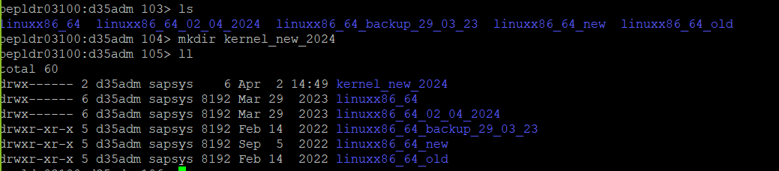

## Locate SAR files and UNCAR

#SAPCAR -xvf

SAPEXE

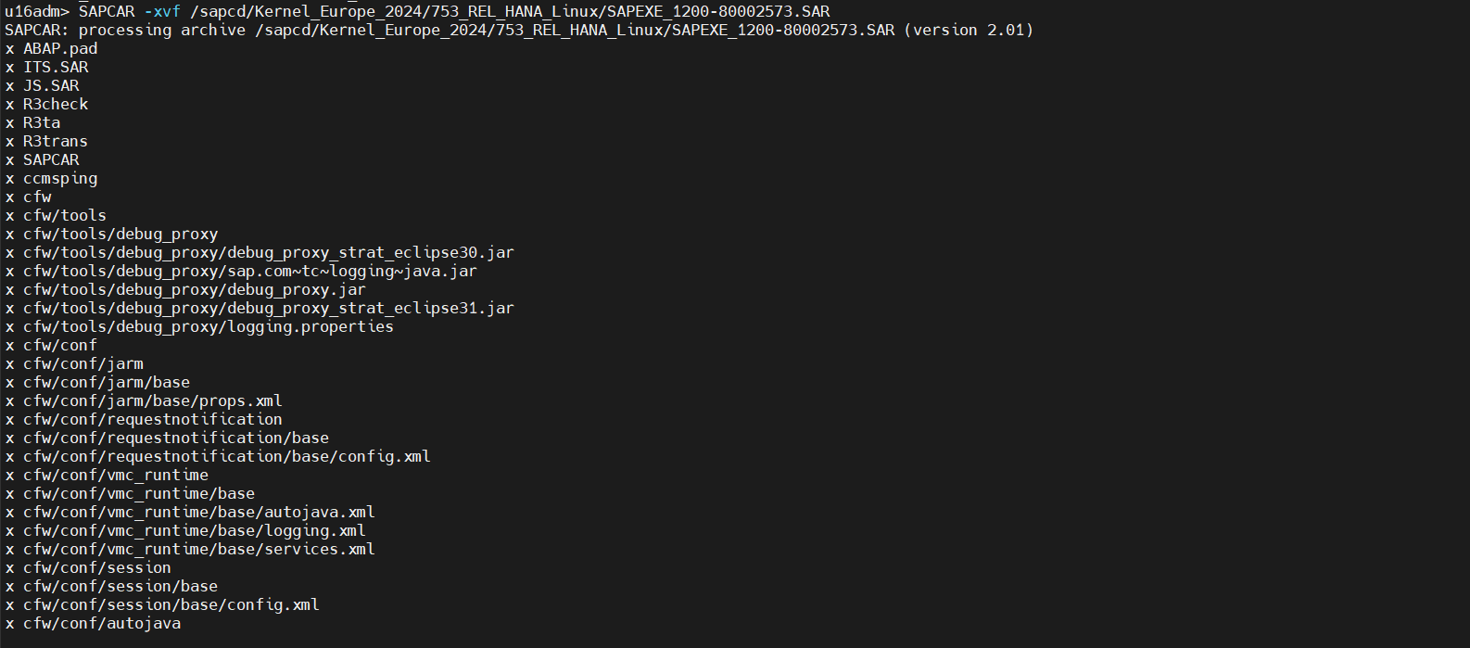

SAPEXEDB & DBSL & DW

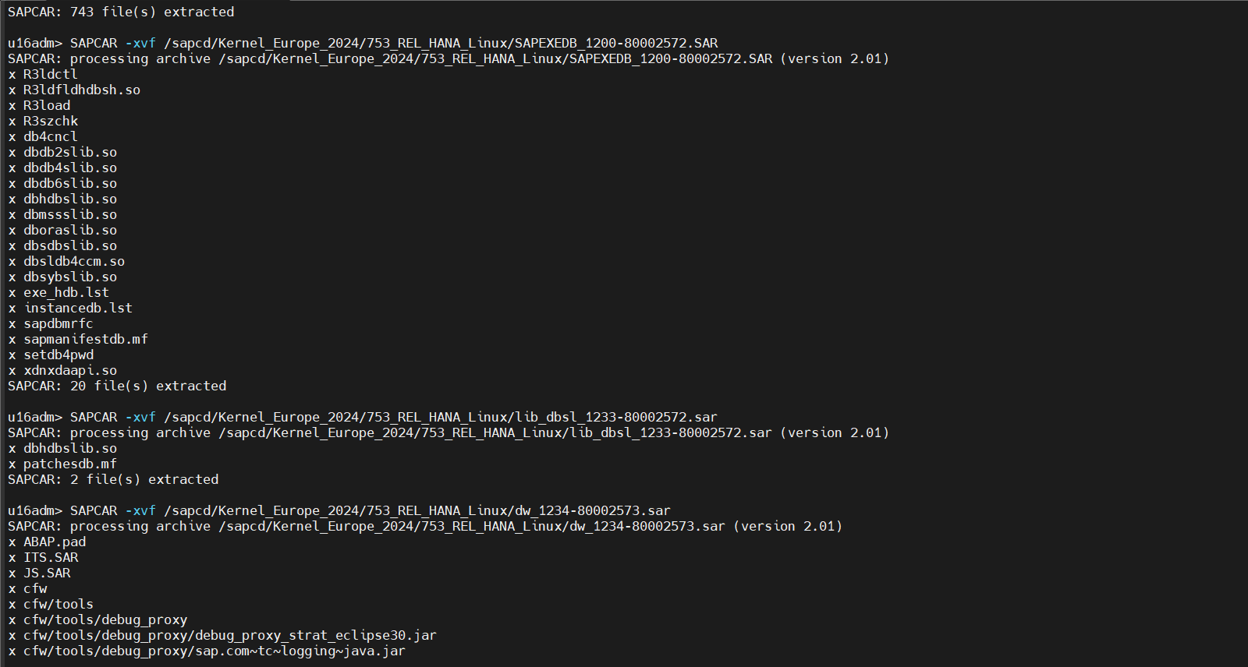

IGS & IGSHELPER

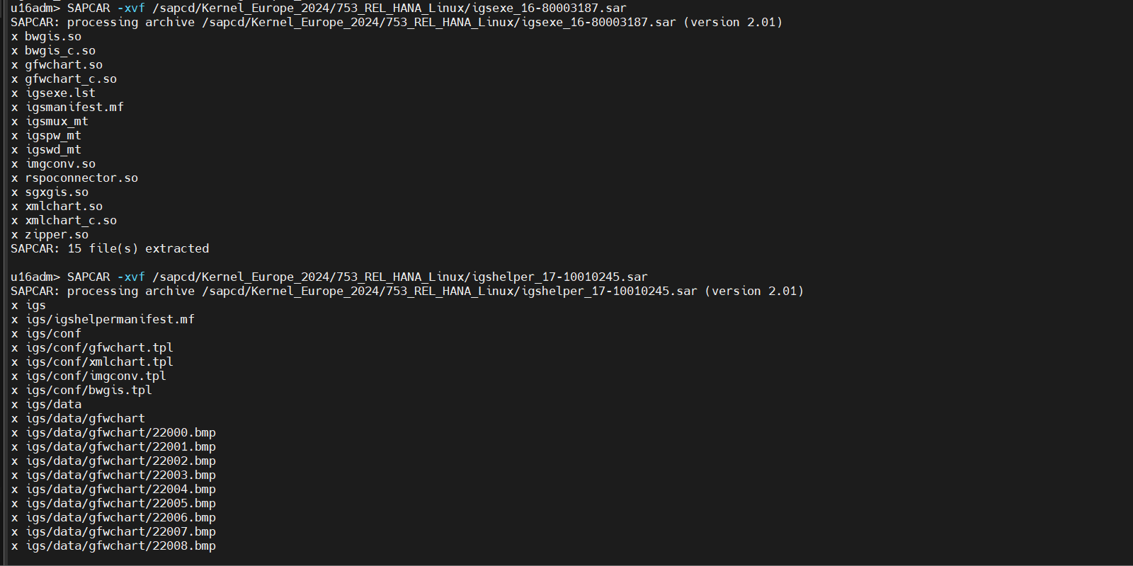

DBATL (if ORACLE)

## Perform basic pre validations on Application

1. SM51
2. SICK
3. SM50
4. ST22
5. SM21
6. SIGS

# Execution (Downtime)

## Stop Application servers

#stopsap r3

## Application servers validations (Kill running services and clean shared memory)

#ps -ef | grep sidadm

#sapcontrol -nr 00,01 -function StopService

#cleanipc 00 remove all

## Move/Change new kernel file to existing kernel folder

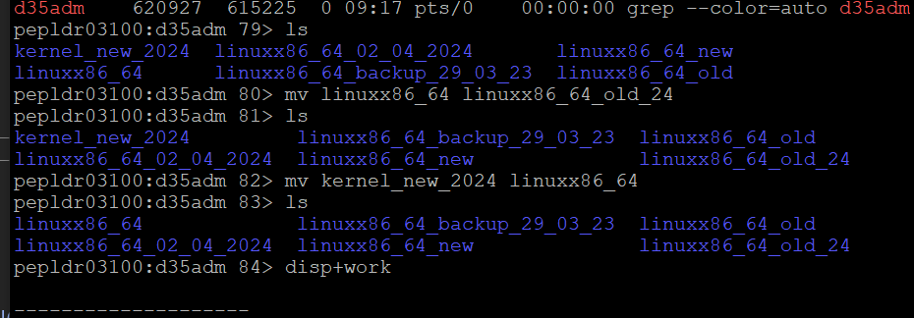

## Verify Kernel, IGS, IGSHELPER version

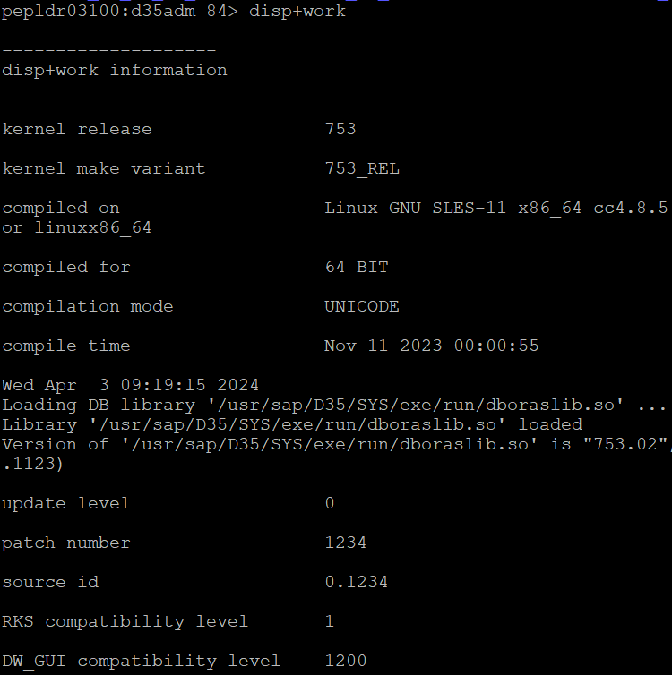

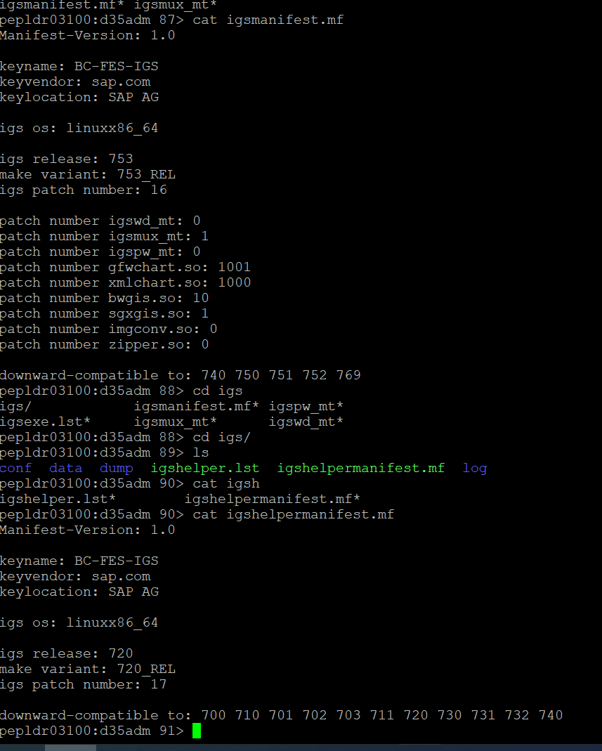

Kernel version after upgrade

IGS version after upgrade

IGS Helper version after upgrade

## Sync new kernel

#cdpro & #sapcpe pf=

## Copy IGS folder from /sapmnt/SID/exe/uc/linux to /usr/sap/D10/ASCS01/exe

## Validate SAP to DB Connection - R3trans -d (if Applicable)

## Start SAP on each SAP Application Server

# Post-checks

For ABAP

1. SM51
2. SICK in all apps
3. System dump ST22
4. System logs SM21
5. Locks Validation SM12
6. Updates- SM13
7. System response time-SMLG
8. Web services SMICM
9. Inbound queues SMQ2
10. Outbound queue SMQ1
11. Transactional RFC SM58
12. XML messages SXMB_MONI
13. SM50- workprocesses
14. SNOTE
15. DB02
16. ST03n
17. ST06
18. RZ12